**Fahd’s Portfolio website**

## Project Portfolio – Project 1:- HTML / CSS Essentials

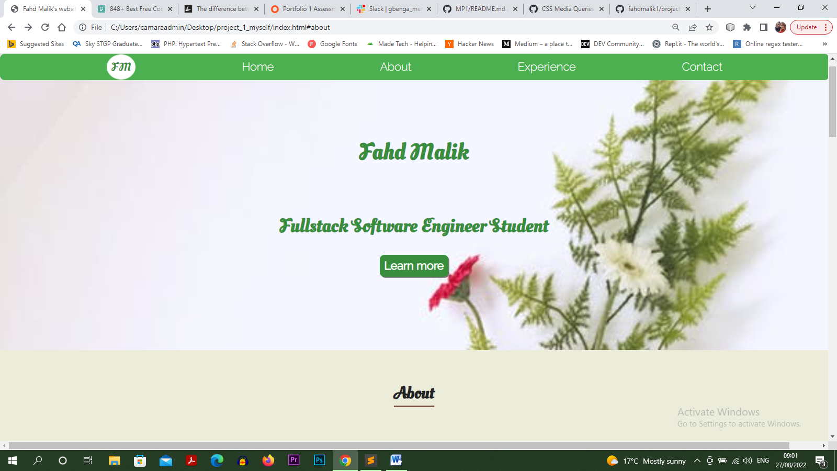

Website presents Fahd’s portfolio as a Full-stack Software Engineer Student. Users will be able to find information about Fahd, and his current journey towards becoming a full-stack software engineer. The website is easy to navigate and finding content is simple and easy.

The main aim of the project is to build a responsive website with HTML and CSS only. There are no other frameworks used in building this site, HTML and CSS only.

The website can be viewed on GitHub pages at the following URL:

[**https://fahdmalik1.github.io/project_1_myself/**](https://fahdmalik1.github.io/project_1_myself/)

## Website owner’s Objective

The main objective behind building this website is to help introduce a Junior Full-stack Software Engineer (Namely: Fahd Malik) to the world. And tell his story on becoming a Full-stack Software Engineer and document his journey along the way and show his evolution throughout the entire process. Which include his achievements and hurdles he faced along the way (please note that at the moment of writing this Fahd is currently still on his journey).

## User Objectives

* The user is able to find information about Fahd Malik (full-stack software engineer).
* The user is able to find out about the current skills that Fahd Malik has and a brief history of his past.
* The user is able to contact Fahd, through a contact form and make enquiries about web development tasks that the user may need done.

## Future User Objectives

* The user can learn more about Fahd and his past and his skills as new information will be added as he progresses.
* The user will be able to view information on past works and projects that Fahd has worked on and completed, as well as new works and projects he is working on. As project page will be added to the website.

## User stories

## As a Web Developer:

* I would like to present myself and the services I offer on the website clearly too potential customers.
* I need to make sure that my current and new customers will find my services professional and that I can help them with their business tasks and marketing objectives, as well as other objectives that they may have.
* I want my customers to be able to learn how to use my website intuitively and easily.
* I would like to build and maintain professional relationships with new and current customers.
* I would like to showcase my work both past and present.

### As a new customer:

* I wish to find information about the web developer and checkout his professional qualifications /skills / experience and his work.
* I would like to contact a professional web developer to build / update my website or websites and expand my business or businesses.

### As a returning customer:

* I need to contact my web developer on a regular basis easily to get updates on work that is in progress and review deadlines.
* I would like to have someone I can trust to carry out regular work.
* I want to be able to refer to friends and other colleagues and acquaintances of work that the web developer has done.

### Structure of the website

The website is designed to be easy and user-friendly on all type of devices. It works fine on desktop. However I have had some difficulties in implementing the media queries for tablet and mobile devices, not to fear, I will fix the issues I have been having with the tablet screen size and mobile screen size by implementing the media queries correctly in a future update. Too make sure that the user has a fantastic user experience on all devices. All parts are designed to achieve maximum user satisfaction. User will get to interact with the links and buttons that have a hover effect applied on them.

**Surface**

**Colours**

Main colours used in the project:

* background colour: #4caf50;
* main font colour: #212121;
* link colour: #FFFFFF;
* hover colour: #4caf50; and font-size is larger;
* main heading colour: #388e3c;

### Fonts

All fonts used in the project were taken from Google Fonts

* As a main font I used Open Sans for paragraphs, and as a backup font sans-serif
* For main headings I used Oleo Script Swash Caps and as backups I used cursive and sans-serif
* For links I used Raleway as main font and sans-serif as backup font

### Images

* All images used in the project were taken from https://www.pexels.com/

# Features

The website is a scrolling website that consists of four sections. Which are accessible from a navigation bar. One page is a thank you page after the contact form has been submitted.

The website has below features:

**Navigation Bar**

On the left hand side is a logo followed by the main navigation links to Home, About, Experience and Contact. All the links take you to the relevant sections of the website very easily.

## Footer

The footer contains the copyright information of the site as well as links to my GitHub page and my LinkedIn profile.

## Technologies used

## HTML5

* As a structure language.

## CSS

* As a style language.

## Google fonts

* As a font resource.

## GitHub

* As a software hosting platform and making the website live and accessible to the public

## Git

I wanted to use git as a version control system to keep track of all the changes while building the project but ran into some difficulties as my computer would not let me push the changes I was making in a periodic manner to GitHub, so I was unable to use git to keep track of my project. However I plan to use git in the future after fixing the issues I have been having with pushing my changes.

**Testing**

I used chrome developer tools throughout the development stages of the project to help me test for issues I have been having with my website, it is where I discovered issues with tablet and mobile screen sizes.

**Issues found during site development**

As mentioned earlier I have been having issues with tablet and mobile devices that the media queries need implementing correctly. The website does not show well on tablet and mobile devices at the moment due to screen sizes issues. I will fix this in future updates.

**Code Validation**

At the end of the project I used the following website to validate my code

* [W3C CSS Validator](https://jigsaw.w3.org/css-validator/) to validate CSS and HTML

**Deployment**

The project is deployed on GitHub pages via logging in into the GitHub website and following the deployment steps on GitHub.

**Screenshots**

